Name: Nam Do

CSU ID: 2594704

CIS408 Lab3

**Problem 1:**

**Source Code:**

**TableTemplate.js:**

function TableTemplate(){

}

TableTemplate.fillIn=function(id,dictionary,columnName){

var columnTemp = columnName;

var noRows=document.getElementById(id).rows.length;

var table=document.getElementById(id).rows[2].cells[0].innerHTML;

// var row1cell=table[0].innerHTML;

var headerRow=document.getElementById(id).rows[0].cells;

var headerEleLength = headerRow[0].innerHTML.length; //string length of header element

for(var i = 0; i < headerRow.length;i++){ //loop through entire header row

var t = headerRow[i].innerHTML.substring(2,headerRow[i].innerHTML.length-2); //substring of string in header cell, exclude "{{" and "}}"

if( t in dictionary){ //check if the header element exist in dictionary object

headerRow[i].innerHTML=headerRow[i].innerHTML.replace(headerRow[i].innerHTML,dictionary[t]); //replace with appropriate key value, {{PartNumber}} --> Part Number

}

if(columnName==headerRow[i].innerHTML && t in dictionary){

for(var g=1; g<noRows;g++){

var temp=document.getElementById(id).rows[g].cells[i].innerHTML;

var temp1=temp.substring(2,temp.length-2);

document.getElementById(id).rows[g].cells[i].innerHTML=document.getElementById(id).rows[g].cells[i].innerHTML.replace(document.getElementById(id).rows[g].cells[i].innerHTML,dictionary[temp1]);

}

}else if(columnName==undefined){

for(var g=1; g<noRows;g++){

var temp=document.getElementById(id).rows[g].cells[i].innerHTML;

var temp1=temp.substring(2,temp.length-2);

document.getElementById(id).rows[g].cells[i].innerHTML=document.getElementById(id).rows[g].cells[i].innerHTML.replace(document.getElementById(id).rows[g].cells[i].innerHTML,dictionary[temp1]);

}

}else if(!columnName in dictionary){ //case when columnName is not a property defined in dictionary, do nothing to column rows

continue;

}else{

continue;

}

}

}

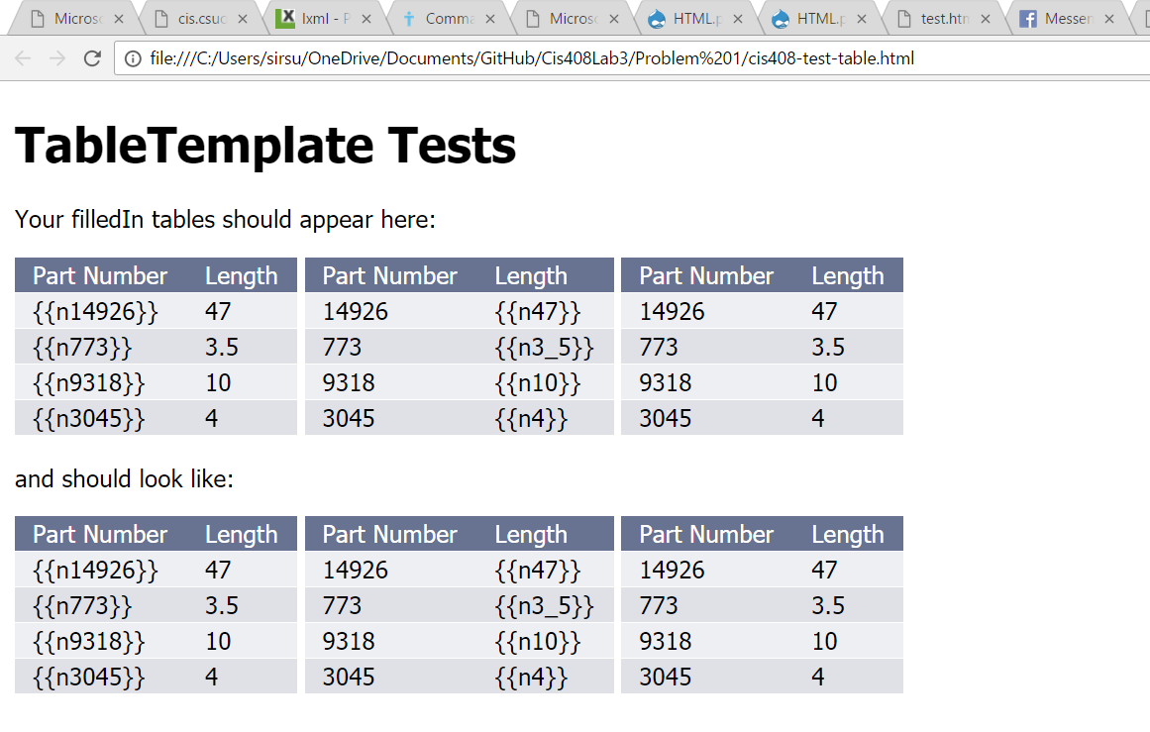

**Problem 2:**

I use lxml and requests in python to pull elements from the html file through XPATH. Then I use a module call HTML to convert python lists into HTML table in a html file.

**Source Code:**

**Probem2.html:**

<script type="text/javascript" src="cis408-template-processor.js"></script>

<script>

var template = 'My favorite month is {{month}} but not the day {{day}} or the year {{year}}';

var dateTemplate = new Cis408TemplateProcessor(template);

var dictionary = {month:'June', day: '20', year:'2015'};

var str = dateTemplate.fillIn(dictionary);

alert(str);

</script>

**Cis408-template-process.js:**

function Cis408TemplateProcessor(template){

if(typeof template!='string'){

throw new Error('String expected');

}

this.template=template;

}

Cis408TemplateProcessor.prototype.fillIn=function(dictionary){

var dictLength=Object.keys(dictionary).length;

for( var x=0; x<3; x++){

var str1="{{";

var target=str1.concat(Object.keys(dictionary)[x],"}}");

template = template.replace(target,dictionary[Object.keys(dictionary)[x]]);

}

return template;

}

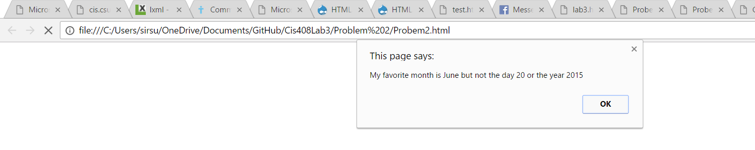

**Problem 3:**

**Source code:**

**Lab3.html:**

<TABLE border="1" cellpadding="4" style="border: 1px solid #000000; border-collapse: collapse;">

<TR>

<TD>George Washington </TD>

<TD>December 8, 1790)</TD>

<TD>file:///C:/Users/Sunnie/Work/ClassNotes/CIS408/Labs/WebScrap/1.html</TD>

</TR>

<TR>

<TD>George Washington </TD>

<TD>October 25, 1791)</TD>

<TD>file:///C:/Users/Sunnie/Work/ClassNotes/CIS408/Labs/WebScrap/2.html</TD>

</TR>

<TR>

<TD>George Washington </TD>

<TD>November 6, 1792)</TD>

<TD>file:///C:/Users/Sunnie/Work/ClassNotes/CIS408/Labs/WebScrap/3.html</TD>

</TR>

<TR>

<TD>George Washington </TD>

<TD>December 3, 1793)</TD>

<TD>file:///C:/Users/Sunnie/Work/ClassNotes/CIS408/Labs/WebScrap/4.html</TD>

</TR>

<TR>

<TD>George Washington </TD>

<TD>November 19, 1794)</TD>

<TD>file:///C:/Users/Sunnie/Work/ClassNotes/CIS408/Labs/WebScrap/5.html</TD>

</TR>

<TR>

<TD>George Washington </TD>

<TD>December 8, 1795)</TD>

<TD>file:///C:/Users/Sunnie/Work/ClassNotes/CIS408/Labs/WebScrap/6.html</TD>

</TR>

<TR>

<TD>George Washington </TD>

<TD>December 7, 1796)</TD>

<TD>file:///C:/Users/Sunnie/Work/ClassNotes/CIS408/Labs/WebScrap/7.html</TD>

</TR>

<TR>

<TD>John Adams </TD>

<TD>November 22, 1797)</TD>

<TD>file:///C:/Users/Sunnie/Work/ClassNotes/CIS408/Labs/WebScrap/8.html</TD>

</TR>

<TR>

<TD>John Adams </TD>

<TD>December 8, 1798)</TD>

<TD>file:///C:/Users/Sunnie/Work/ClassNotes/CIS408/Labs/WebScrap/9.html</TD>

</TR>

<TR>

<TD>John Adams </TD>

<TD>December 3, 1799)</TD>

<TD>file:///C:/Users/Sunnie/Work/ClassNotes/CIS408/Labs/WebScrap/10.html</TD>

</TR>

<TR>

<TD>John Adams </TD>

<TD>November 11, 1800)</TD>

<TD>file:///C:/Users/Sunnie/Work/ClassNotes/CIS408/Labs/WebScrap/11.html</TD>

</TR>

<TR>

<TD>Thomas Jefferson </TD>

<TD>December 8, 1801)</TD>

<TD>file:///C:/Users/Sunnie/Work/ClassNotes/CIS408/Labs/WebScrap/12.html</TD>

</TR>

<TR>

<TD>Thomas Jefferson </TD>

<TD>December 15, 1802)</TD>

<TD>file:///C:/Users/Sunnie/Work/ClassNotes/CIS408/Labs/WebScrap/13.html</TD>

</TR>

<TR>

<TD>Thomas Jefferson </TD>

<TD>October 17, 1803)</TD>

<TD>file:///C:/Users/Sunnie/Work/ClassNotes/CIS408/Labs/WebScrap/14.html</TD>

</TR>

<TR>

<TD>Thomas Jefferson </TD>

<TD>November 8, 1804)</TD>

<TD>file:///C:/Users/Sunnie/Work/ClassNotes/CIS408/Labs/WebScrap/15.html</TD>

</TR>

<TR>

<TD>Thomas Jefferson </TD>

<TD>December 3, 1805)</TD>

<TD>file:///C:/Users/Sunnie/Work/ClassNotes/CIS408/Labs/WebScrap/16.html</TD>

</TR>

<TR>

<TD>Thomas Jefferson </TD>

<TD>December 2, 1806)</TD>

<TD>file:///C:/Users/Sunnie/Work/ClassNotes/CIS408/Labs/WebScrap/17.html</TD>

</TR>

<TR>

<TD>Thomas Jefferson </TD>

<TD>October 27, 1807)</TD>

<TD>file:///C:/Users/Sunnie/Work/ClassNotes/CIS408/Labs/WebScrap/18.html</TD>

</TR>

<TR>

<TD>Thomas Jefferson </TD>

<TD>November 8, 1808)</TD>

<TD>file:///C:/Users/Sunnie/Work/ClassNotes/CIS408/Labs/WebScrap/19.html</TD>

</TR>

</TABLE>

**Problem3.py:**

from lxml import html

import requests

import HTML

page = requests.get('http://cis.csuohio.edu/~sschung/CIS408/InfoUnionAddressJefferson.html' )

tree = html.fromstring(page.content)

name = tree.xpath('//a/text()')

link = tree.xpath('//a/@href')

newlist = name[4:]

newLink = link[3:]

nameList=[]

for num in range(19):

nameList.append(newlist[num].split("("))

for i in range (19):

nameList[i].append(newLink[i])

htmlcode = HTML.table(nameList)

Html_file=open("lab3.html","w")

Html_file.write(htmlcode)

Html_file.close()

